**Wireless V2I Communication Protocols for Driver Assistance**

Conor Power1, Scout Case2, Daniel Collins1, James Tompkins2

1 School of Science and Computing, Waterford Institue of Technology, Waterford, Ireland

2 College of Science and Engineering, Central Michigan University, Mt. Pleasant, USA

**Abstract:**

The project presents an application of utilization of multiple IoT applications. The project will be based around the idea driver safety in the real world. There will be the use of a Raspberry Pi that will be programmed to transfer from different traffic light states (red, yellow, or green). There is a circuit in which displays the traffic light signals using red, yellow and green LED’s. The light systems will be pushed to an MQTT server broker. On the vehicle side, we will utilize a Raspberry Pi car. The Raspberry Pi car will be also connected to the MQTT broker. The car will constantly be searching for the traffic lights state from the broker. Once a signal is received, the car will be programmed to adjust its speed accordingly. Finally, the traffic light will have a GPS chip connected to it. That sensor will be transmitting its location to the Raspberry Pi on the car. Using the data it has received, it will make its decision on stopping or travelling through the light.

**Introduction:**

The main purpose of the project is to assist the driver when approaching traffic lights by notifying the driver in advance of the state of the of the traffic lights ahead. The proposed concept is applicable in an inner-city area, where speeds are lower which allows manipulation of the vehicles speeds possible. Also, the slower speeds will allow the GPS location to be more accurate.

For a visual display of the traffic lights we will use an Raspberry Pi circuit connected to red, yellow and green LEDs. The Raspberry Pi will also be programmed to control the states of the traffic lights system changing periodically to mimic an actual traffic light system. The traffic light states will be pushed to an online MQTT broker. This broker will be the connection between the traffic light and the vehicle which is approaching it.

The MQTT broker will search for a device to connect with. When it finds the Raspberry Pi onboard the vehicle it will send a traffic light status update to to the Raspberry Pi. The Raspberry Pi, which will have access to the internet, will read the status and determine the vehicles next movements. The vehicle will then determine the GPS distance between itself from the GPS sensor located on the traffic light. Depending on the location and traffic light status, it will determine if it need to continue accelerating, slow down, or stop the vehicle completely.

An RC car could serve as a substitute for a vehicle for testing. An accelerometer could be attached to the RC car. The motors of the car can then be signaled to slow down or stop if the lights ahead are amber or red. If the lights are green the car can be notified to continue. The traffic light will be displayed using a Raspberry Pi traffic light simulator.

**Figure 1 and 2:** Shows the data transmission and flow chart of the project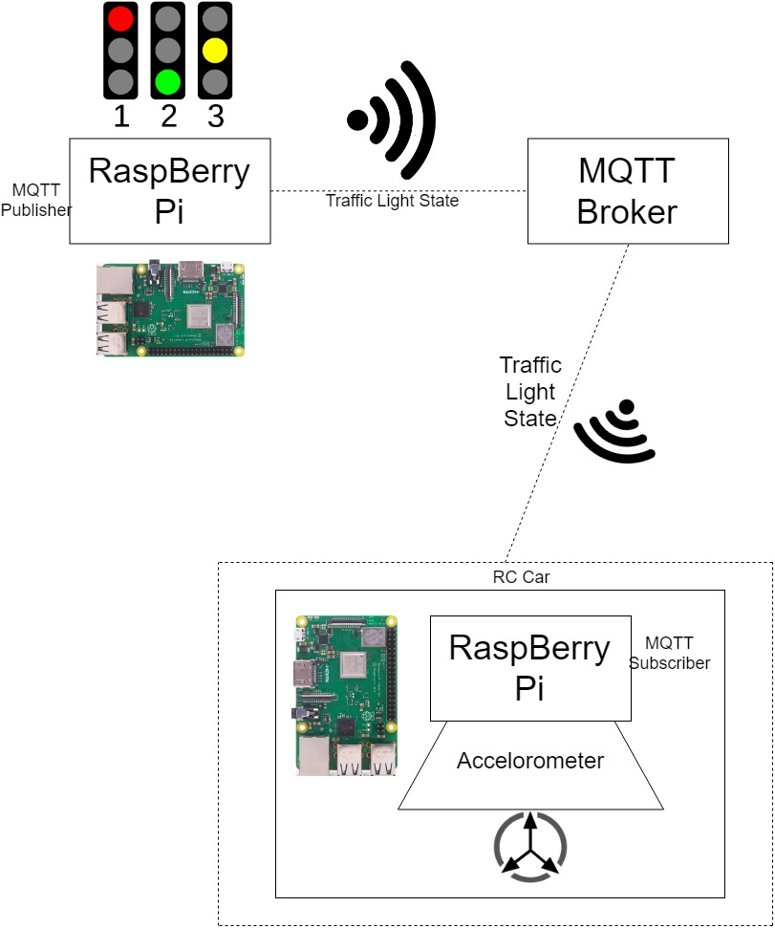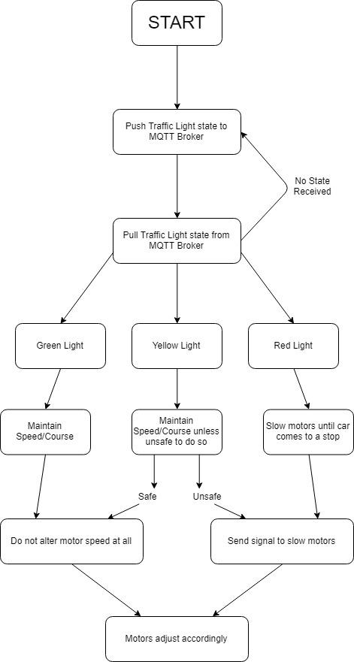

**Scope:**

For the successful completion of this project, there are some key areas to focus on. Connecting the Raspberry Pi to a MQTT broker service. Then using the MQTT broker as the data transfer application, it will have a traffic state ready to be broadcasted to the vehicle. The vehicle will then make a decision based on the state using distance from the light as a factor as well.

Once the data is on the MQTT broker, the next step is having the vehicle receive the data. The vehicle will constantly be searching for the signal from broker. All of this is happening while the vehicle is also receiving the data from the GPS sensor on the traffic light. A formula will be used to determine the vehicles next action based on the conditions.

When the data is parsed, relevant corrective action needs to be taken with respect to the state of the light. Using the speed calculated by the accelerometer, if the car is deemed to be travelling too fast, the motors will be slowed down by the Raspberry Pi. The car will be fully autonomous when coming up to the traffic light and will not need user assistance to stop the vehicle.

**Rationale:**

The conceptualization of this project was based around the conversion of the typical car from manual to autonomous, while also trying to lower human error as a cause of car crashes. This idea could be easily manipulated to include all forms of traffic signs/signals.

With the constant amount issues of vehicular traffic, especially in highly populated areas this could be utilized to minimize traffic violations, speed up traffic, and inevitably make driving a more safe, enjoyable experience for any of the users.

Another motive for choosing this project is the crossover between the Computer Science students from WIT and the Engineering students from CMU. By constructing an RC car, we are bringing in the skills of the Engineering students to link the Raspberry Pi to the motors and accelerometer and using the Raspberry Pi board with connections to the MQTT broker. Utilizing the skills from all members of the team, we will be able to make this project a viable option for traffic safety. All members will also get to expand on their knowledge which can be beneficial as we progress our learning.

**Goals:**

There are three main goals in conducting this project. Firstly, we would like to evaluate the usefulness of the GPS sensor. We would like to test and track its accuracy and to highlight its potential strengths and weaknesses. One example of a weakness from a previous study being “Moreover, most of the assessments were done on a predefined route or by simulations. Furthermore, none of the solutions applies information about an actual speed limit of road” [3]. The success of this goal will be determined by our ability to establish a connection and transmit the location. This can cause issues with establishing a speed of the vehicle. If the GPS unit does not track frequently it may provide us with data thats to far from the past. Ways to eliminate this research are being researched.

Another goal of conducting our project is to circumvent or limit the time-consuming effect of the handshake protocol. “Measuring handshake time between devices is an important test when it comes to implementing a communication technology in a vehicular environment characterised by a small window in time in which a vehicle can transmit and receive data to/from road infrastructure equipment. As in many applications the amount of data that is to be transmitted is not high, the communication handshake appears to be the main parameter to be considered in deciding the proper communication technology to be implemented in vehicular environment”[2]. We can evaluate the success of this goal by the ability of our Raspberry Pi to connect to the MQTT broker and interpret the data in time. This will help eliminate and test possible accuracy errors due to having poor timing. Poor timing can result in false data transmission due to the constant changing in the traffic light.

Lastly, we have the goal of successfully implementing an accelerometer onboard an RC car which will measure the acceleration of the car, using the car as a model replacing a real car in our testing process. Considering the speed measured by this sensor we could slow down or stop the motors in the RC car in accordance with the state of the traffic lights. The accelerometer will control how much power is being sent to the wheels. This will be the final step in the process of our project and the most important one. Since the car will always be searching for the data, it will also know when to begin accelerating again.

**Current Results:**

On the software side of the project, the connection between the traffic light and raspberry pi has been established. The current code is written in the language C++, but the group hopes to convert it over to python coding. Because these languages have very key differences, converting the current code over to a completely functional python code will take some researching and tests. The reason for the conversion of the current code, is due to the relative simplicity of Python and the use of a Raspberry pi for the microprocessor controlling the car. The team also found a suitable MQTT broker to start running tests with to analyze its reliability and power.

On the hardware side of the project, the Raspberry pi car connection was being tested. The group successfully used the Raspberry Pi’s onboard Wi-Fi to connect to the campus Wi-Fi. With this, the car will be able to piggyback off a stronger Wi-Fi to receive and interpret signals from the broker at a faster rate. We also began to research the GPS integration, based on the signal from the traffic light. This section of code will determine the action the servo motors driving the Raspberry pi car.

**Evaluation:**

The group is on progress to finish the project in the allotted amount of time left in the class. Some of the upcoming challenges are hosting the traffic light state in MQTT broker, code conversion, analyzing MQTT, and the Pi car interpretation of the signal. The group has encountered similar challenges through various classes and projects, so the turn around for these challenge should be relatively quick. We are also looking into setting up protocols for the GPS’s accuracy since it has a discrepancy of about plus or minus ten feet. Knowing this, we will construct an internal equation that can adjust the location depending on the displacement. With this adjustment, the true distance between the light and the vehicle can be properly gauged.

**Discussion:**

The group did more research in regards to the use of the GPS module to track the position of the car for improved accuracy. After searching through similar research papers, the team learned that for a similar measurement, a iCar III OBD Scan-tool adapter [3] was used to track the speed of the vehicle. This adapter reads the real time diagnostic codes and variables for the vehicle. For the project, we will just use an accelerometer which may prove to be a less accurate assessment of speed. In the same paper, the researchers also managed to connect the GPS module through UART, to a Raspberry Pi, using NMEA 0183. This gives the group a place to start searching, for a solution to the communication difficulties occurring between the Raspberry Pi car and signals received from the broker.

**Reference Sources:**

[1] Gheorghiu R.A., Iordache V. & Cormos A.C. (2017) “Analysis of handshake time for bluetooth communications to be implemented in vehicular environments”. [Online] Available at: <https://ieeexplore.ieee.org/document/8075955>

[2] Jachimczyk B., Dziak D., Czapla J., Damps P., & Kulesza W. (2018) “IoT On-Board System for Driving Style Assessment”. [Online] Available at:

<https://www.mdpi.com/1424-8220/18/4/1233/htm>

[3] Bengler, Klaus. “Three Decades of Driver Assistance Systems: Review and Future Perspectives.” Three Decades of Driver Assistance Systems: Review and Future Perspectives - IEEE Journals & Magazine,<https://ieeexplore.ieee.org/abstract/document/6936444>

Carmona, Juan, et al. “Embedded System for Driver Behavior Analysis Based on GMM.” IEEE Xplore Digital Library, IEEE, 8 Aug. 2016,<https://ieeexplore.ieee.org/abstract/document/7535365>

[4]Gheorghiu R.A. & Minea M.  
 (2016), “Energy-efficient solution for vehicle prioritisation employing  
ZigBee V2I communications”. [Online] Available at:<https://ieeexplore.ieee.org/document/7754691>

[5] Hallmark, Shauna, et al. “Safety Effectiveness of Stop-Sign  
Beacons : A Cross-Sectional Study.” Welcome to ROSA P, Midwest Transportation  
Center, 2 Feb. 2018,<https://rosap.ntl.bts.gov/view/dot/35595>

[6] Harrison, et al. “Method and Apparatus for  
Providing a Proximity Alert to the Operator of a Vehicle.” Free Patents Online,  
4 Sept. 2018, [www.freepatentsonline.com/10068473.html](http://www.freepatentsonline.com/10068473.html).

[7] Iordache V., Gheorghiu R.A., Minea M.  
& Cormos A.C. (2017), “Field testing of Bluetooth and ZigBee technologies  
for vehicle-to-infrastructure applications”. [Online] Available at:<https://ieeexplore.ieee.org/document/8246274>

[8] Lee, Jin-Shyan, et al. “A Comparative  
Study of Wireless Protocols: Bluetooth, UWB, ZigBee, and Wi-Fi.” A Comparative  
Study of Wireless Protocols: Bluetooth, UWB, ZigBee, and Wi-Fi - IEEE  
Conference Publication, 3 Nov. 2007,<https://ieeexplore.ieee.org/abstract/document/4460126>

[9] Pu, Cuiping, et al. “Design of Vehicle  
Tracking System Based on Ibeacon.” IEEE Xplore Digital Library, IEEE, 2017, [www.revistadelafacultaddeingenieria.com/index.php/ingenieria/article/download/2115/2075](http://www.revistadelafacultaddeingenieria.com/index.php/ingenieria/article/download/2115/2075)